 | JOHN CURTIN COLLEGE OF THE ARTS  CHEMISTRY YEAR 11 2017  Task 7  Research Assignment - Nanotechnology and Biofuels

Student name: _______________________________ Due date: ______________

This investigation is divided into two:
Part 1 Nanotechnology.
- Use your Nelson text (pg 19 – 20) and the video links below, answer the questions on graphene and carbon nanotubes.
https://www.youtube.com/watch?v=WFacA6OwCjA

https://www.youtube.com/watch?v=hRFyc45t1-c

https://www.youtube.com/watch?v=H-a2dC9Bgak

https://www.youtube.com/watch?v=lU9kvDZwsX4

- Nanoparticles are frequently used in sunscrens. Read the information sheet attached to answer the questions on this use.

- Research another use of nanoparticles.

Part 2 Use the web reference to biofuels (http://biofuel.org.uk/how-are-biofuels-produced.html) to answer the questions on the chemistry of biofuels. (attached sheet)

The investigation will be followed by a validation test. (You really need to know and understand what you have written in this assignment.).
The completed assignment is to be handed in on the day of the test.

A copy of this assignment will be placed on Connect.

PART 1: Research questions on nanotechnology

1. Carbon nanotubes (CNT’s) are allotropes of carbon. Diamond and graphite are also allotropes of carbon. What does it mean by allotropes?
2. Describe the structure and bonding in graphene. Include a labelled diagram showing the structure of graphene. The diagram should show the bonding structure clearly and accurately and features should be labelled.
3. Describe the structure and bonding in carbon nanotubes. (no diagram necessary)

4. Describe the structure and bonding in Fullerenes, for example the buckeyball. (no diagram necessary)

5. Construct a T-chart (similar to the one below) for graphene, carbon nanotubes and fullerenes that relates the uses of the material to its bonding structure and the resulting properties (eg; hardness, electrical conductivity, strength). You need to describe five uses in total, and include at least one used for each structure.

STRUCTURE | USES | EXPLANATION OF PROPERTIES  RELATING TO USE

6. Define the term 'nanoparticles'.

7. Nanoparticles have many applications and uses, and more are being developed all the time.
One use for nanoparticles is in many sunscreens. Referring to the article ‘How safe is your sunscreen’ answer the following:

- Why are nano-sized particles more effective than macro or micro sized particles of the same substance.
- What are the advantages of using sunscreens containing nanoparticles?
- Summarise the case for and against the safety of using nanoparticles in sunscreen.

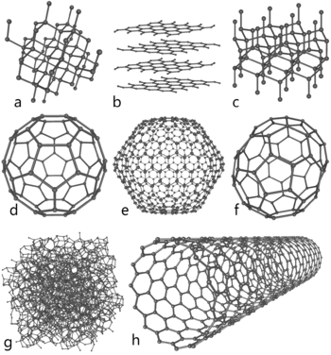

a) diamond; b) graphite; c) lonsdaleite; d-f) buckyballs (C60, C540, C70);
g) amorphous carbon; h) carbon nanotube.

